Coding portion of project :

Analog pin-6

Digital pin-14

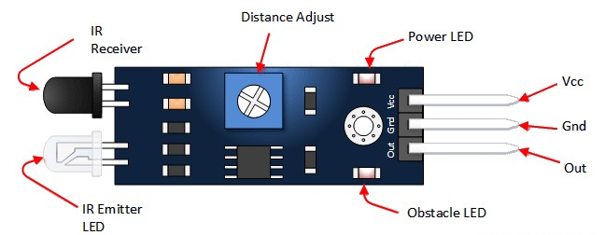

Code:

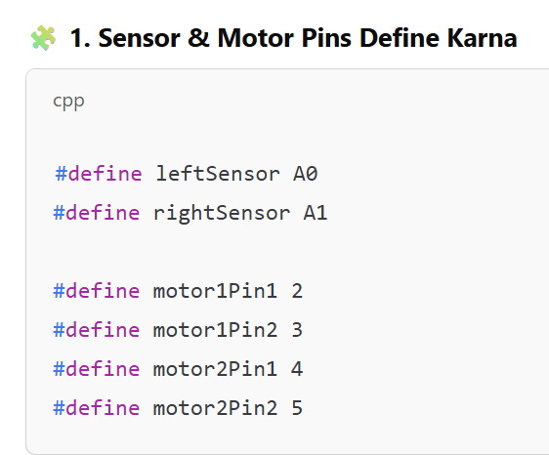

Yeh humne **IR sensors** ke liye input pins aur **motors** ke liye output pins define kiye.

**Interview question :**

**• Coding / Logic:**

* Line following ka logic kya tha?
* Agar dono sensors white surface detect karte hain toh robot kya karega?
* Agar left sensor black aur right sensor white detect karta hai toh kya hoga?
* Tumne robot ko sharp turn kaise karwaya?

Code me digitalRead() aur digitalWrite() ka kya matlab hai?

**•**

**2. Setup Function – pinMode & Serial Start:**

**setup() function sirf ek baar chalta hai** – yahan hum sensor input aur motor output declare karte hain.

**9600-** Isme ek baud rate set karna padta hai — matlab kitni speed se data transfer hoga.

**3. loop: jab tak chalta rahega board on hai**

4: call function :

**Prerequisite: motor-** power-5 volt (high) , ground -0(low) – motor start basic concept

**Sharp turn ke liye**, ek motor ko **forward** chalana padta hai aur doosri motor ko **backward** chalana padta hai.

digitalWrite():

iska matlab hai **us pin ko 5 volt de do**.

ka matlab hai **us pin ko 0 volt (ground) kar do**.

# IoT Vehicle Accident Detection Tracking System

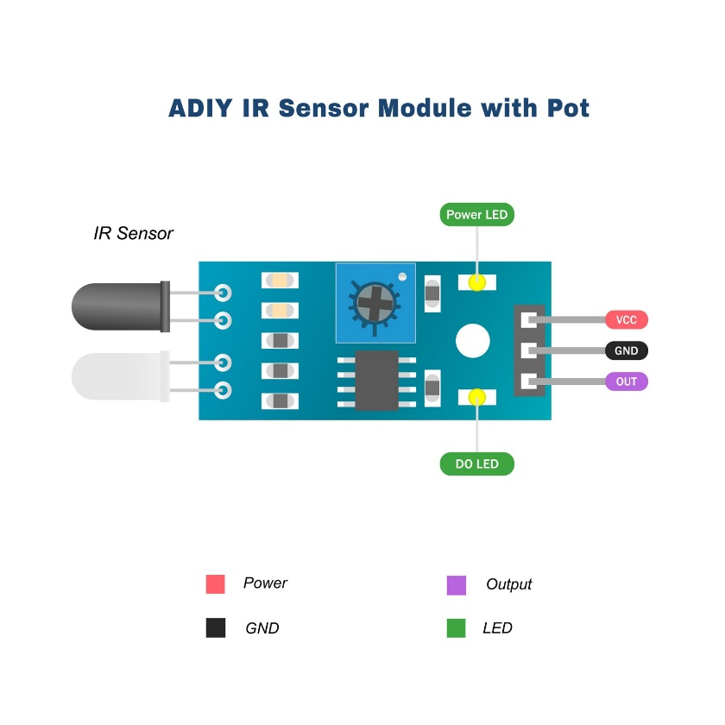

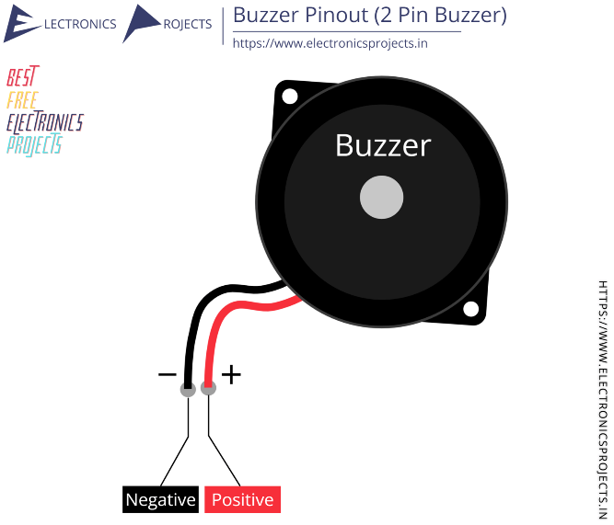

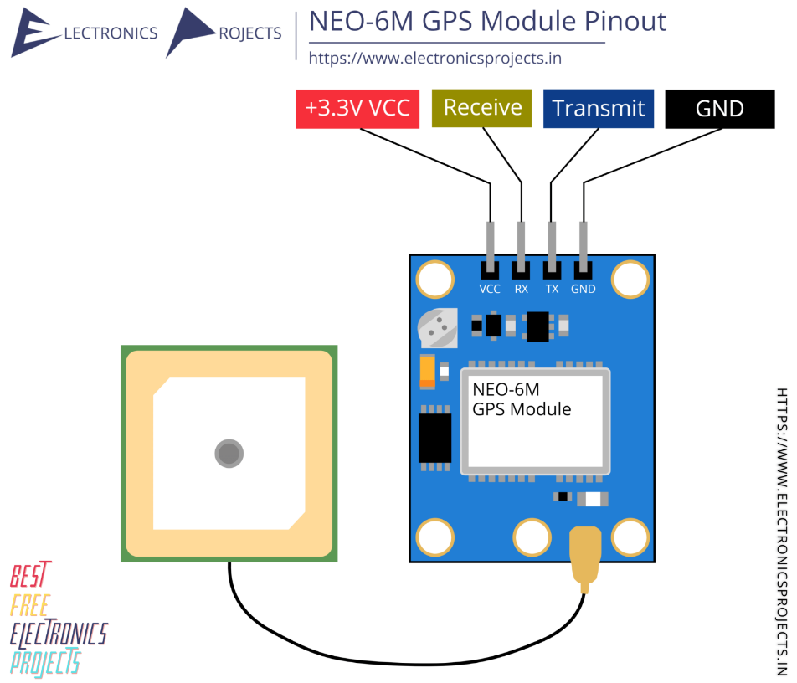

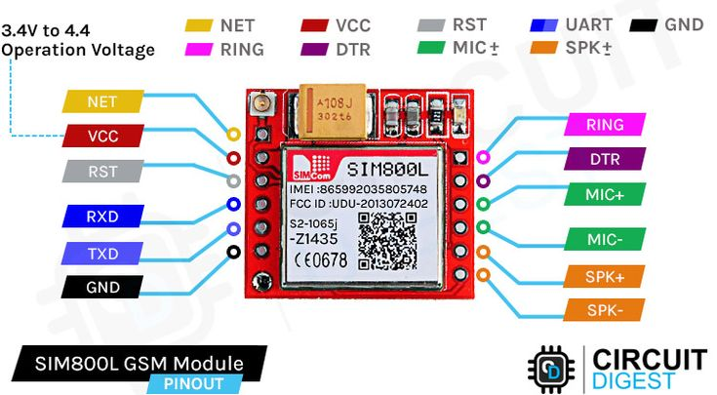

Accelerometer:

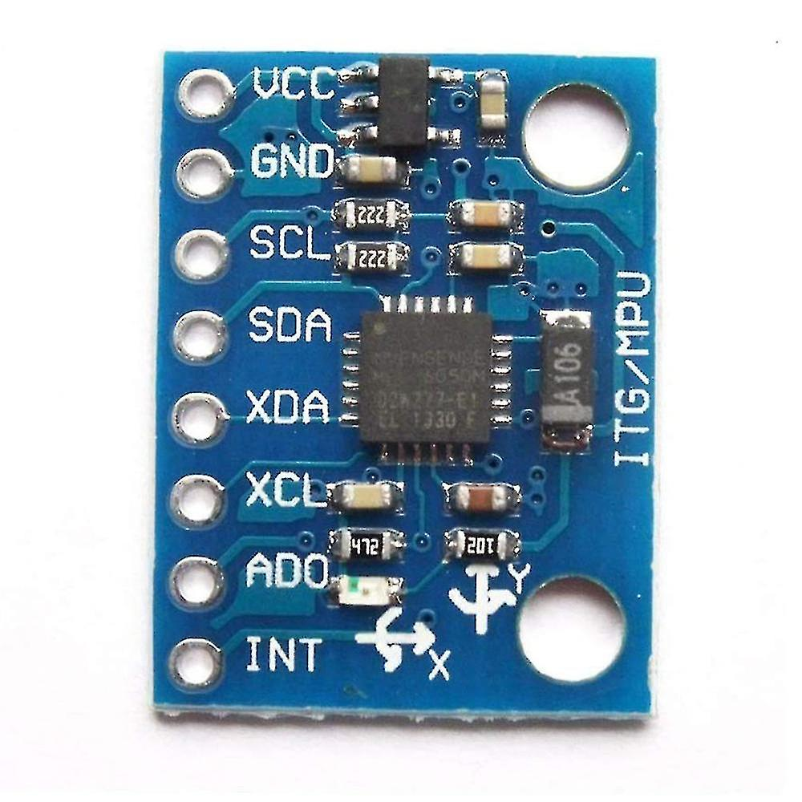

Gas sensor : 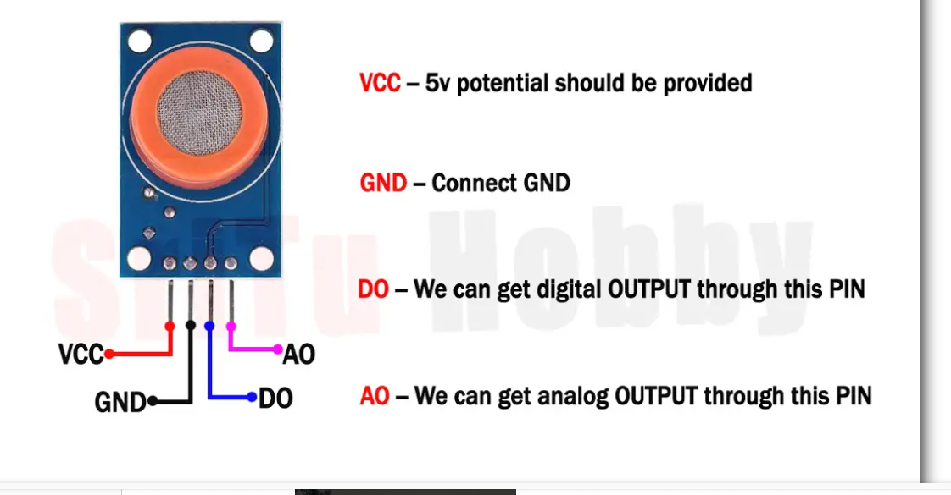

Code:

#include <Wire.h>: •

- It allows **I2C communication** between your **Arduino** and devices like **MPU6050( acceleoneter)**.

-MPU6050 communicates using **SDA (A4)** and **SCL (A5)** pins over I2C.

**#include <MPU6050.h>**

**📌 Purpose:**

* This is a library that **makes it easy to access data** from MPU6050 (like ax, ay, az).
* It simplifies reading **acceleration and gyroscope values**.

**Ir sensor** • It gives a value between **0 to 1023** depending on the light received (typically from IR reflection from the eye).

• **Aankh khuli (open)** hoti hai to **IR rays reflect hoti hain** aur receiver tak pahuchti hain.

• 😴 **Aankh band (closed)** hoti hai to reflection **nahi hoti**, to IR rays receiver tak **nahi pahuchti**.

| **Voltage** | **AnalogRead Value** |
| --- | --- |
| 0V | 0 |
| 2.5V | 512 |
| 5V | 1023 |

Accelertion:

.function calling :

Smart shelter :

**DHT11 / DHT22 Sensor**  
– Measures temperature and humidity inside the shelter.

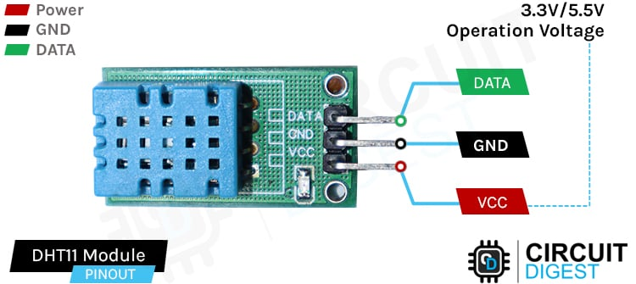

**Gas Sensor (MQ-2 / MQ-135)**  
– Detects harmful gases (like smoke, CO₂) for air quality monitoring.

**Ultrasonic Sensor (HC-SR04)**  
– Used to detect crowd levels or object distance (for occupancy control).

**GPS Module (Neo-6M)**  
– Tracks the location of the shelter and helps guide victims.

**GSM Module (SIM800L / SIM900A)**  
– Sends alert messages to authorities or affected people.

We are using in resume only –

Rain sensor :

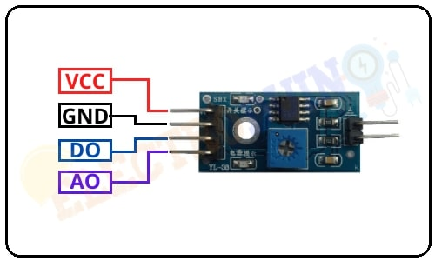

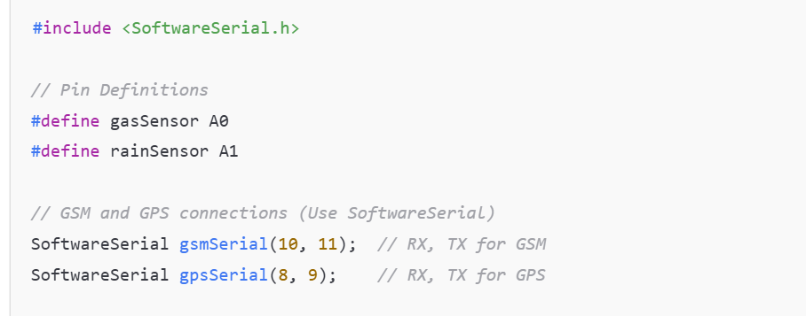

**Automated Data Extraction from Online Stores Using UiPath RPA**